EXPT NO:7 | IMPLEMENT ADVANCED CHART TYPES USING TABLEAU AND POWER BI
DATE: 14.08.2026

PRE-LAB QUESTIONS (PROVIDE BRIEF ANSWERS TO THE FOLLOWING QUESTIONS)

- What is data integration in the context of Business Intelligence (BI)?

Data integration is the process of combining data from different sources into a single, unified system. In BI, it allows organizations to analyze data from sources such as databases, Excel files, cloud applications, and APIs together.

- Explain the difference between a join and a data blend in Tableau.

Join: Combines tables using a common field before or during data preparation. It works at the row level.
Data Blend: Combines data from different data sources using a common field after the sources are already separate. It is useful when the data cannot be directly joined.

- What are relationships and cardinality (e.g., one-to-many, many-to-many) in Power BI's data model?

A relationship connects two tables using a common column. Cardinality defines how records in the tables are related:
- One-to-one (1:1): One record matches one record.
- One-to-many (1:M): One record matches multiple records.
- Many-to-many (M:M): Multiple records in one table match multiple records in another.

- Why is data quality (e.g., consistent naming conventions, data types) crucial when integrating data from different sources?

Good data quality ensures that the integrated data is accurate, consistent, and reliable. Consistent naming conventions, correct data types, and proper formatting prevent errors, duplicate records, and incorrect BI analysis.

- Name two common challenges encountered during data integration.

- Inconsistent data formats and data types across different sources.
- Duplicate or missing data, which can affect the accuracy of analysis.

IN-LAB EXERCISE:
OBJECTIVE:
To connect, combine, and model data from multiple sources in Tableau and Power BI and create a unified, comprehensive dashboard for holistic analysis.

PROCEDURE:
- Data Collection:
  - Import two datasets:
    - Dataset 1: Sales Data (CSV) → Order ID, Order Date, Region, Sales Amount
    - Dataset 2: Regional Sales Targets (Excel) → Region, Sales Target, Target Year
- Data Preparation and Transformation:
  - Clean datasets (e.g., standardize "N. America" → "North America").
  - Ensure correct data types (numeric for Sales, date for Order Date).
  - Handle missing values appropriately.
- Data Integration and Modeling:
  - Tableau: Create a join/relationship on the Region field in the Data Source pane.
  - Power BI: Use the Model view to create a relationship on Region; define cardinality (e.g., many-to-one).
- Create Calculated Fields for Comparison:
  - Target Achievement % = (SUM(Sales) / SUM(Sales Target)) * 100
  - Sales vs. Target Variance = SUM(Sales) - SUM(Sales Target)
- Design a Comprehensive Dashboard:
  - Combine visuals from both sources.
  - Add KPI cards: Total Sales, Overall Target Achievement %.
  - Use gauge/bullet charts for region-wise target performance.
  - Combined bar chart: Actual Sales vs. Target by Region.
  - Map visualization: Sales vs. Target Variance by region.
- Validate Data Integrity:
  - Cross-check joined data for accuracy.
  - Ensure dashboard filters correctly update visuals.
- Publishing and Sharing:
  - Tableau: Publish to Tableau Public or Server.
  - Power BI: Publish to Power BI Service and share.

Experiment Datasets:
  - Dataset 1: Retail Sales Data (CSV) → Order ID, Order Date, Region, Sales
  - Dataset 2: Regional Sales Targets (Excel) → Region, Sales Target, Target Year

Power BI:

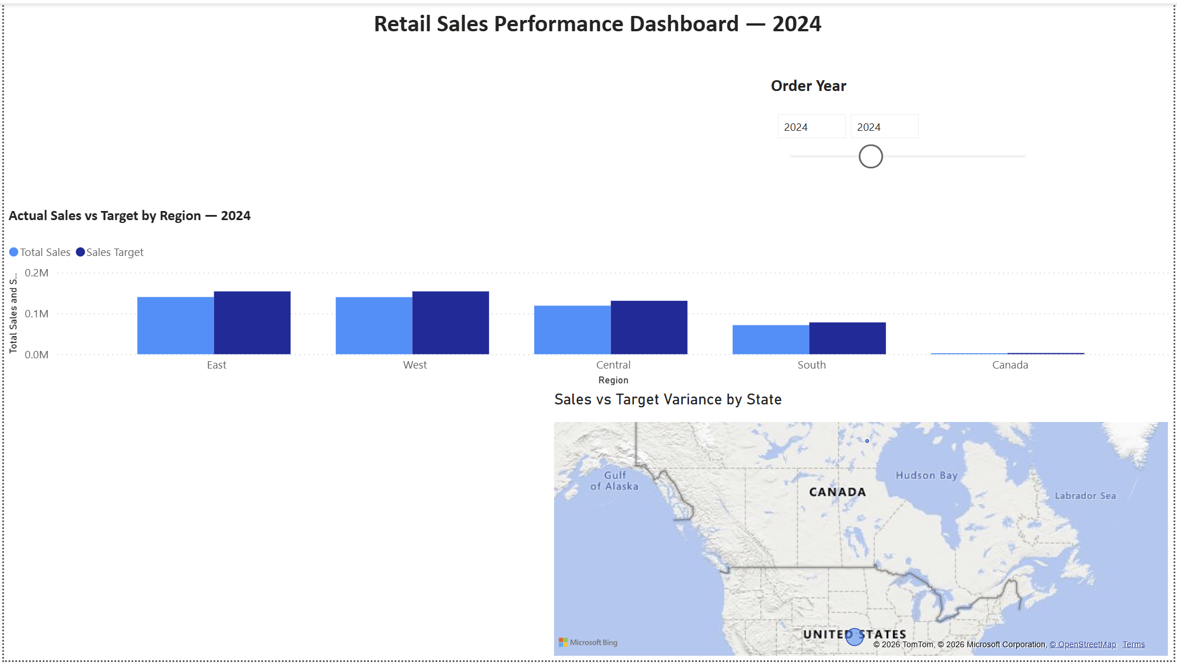

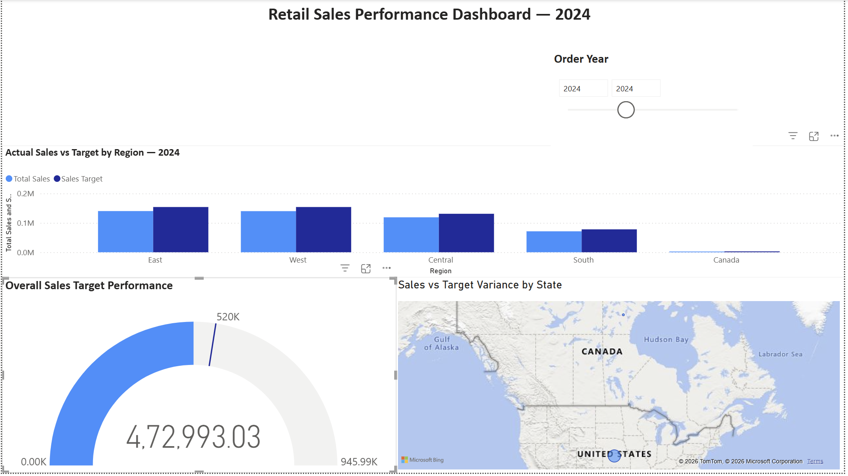

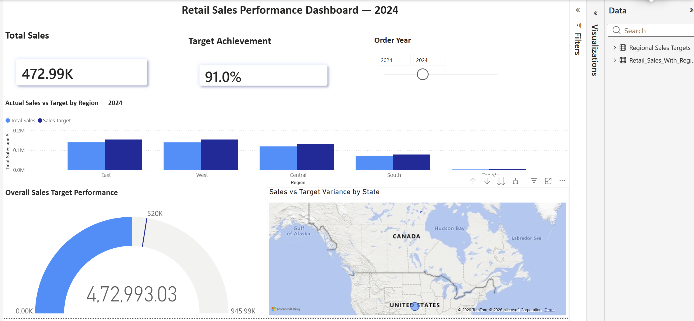

Tableau:

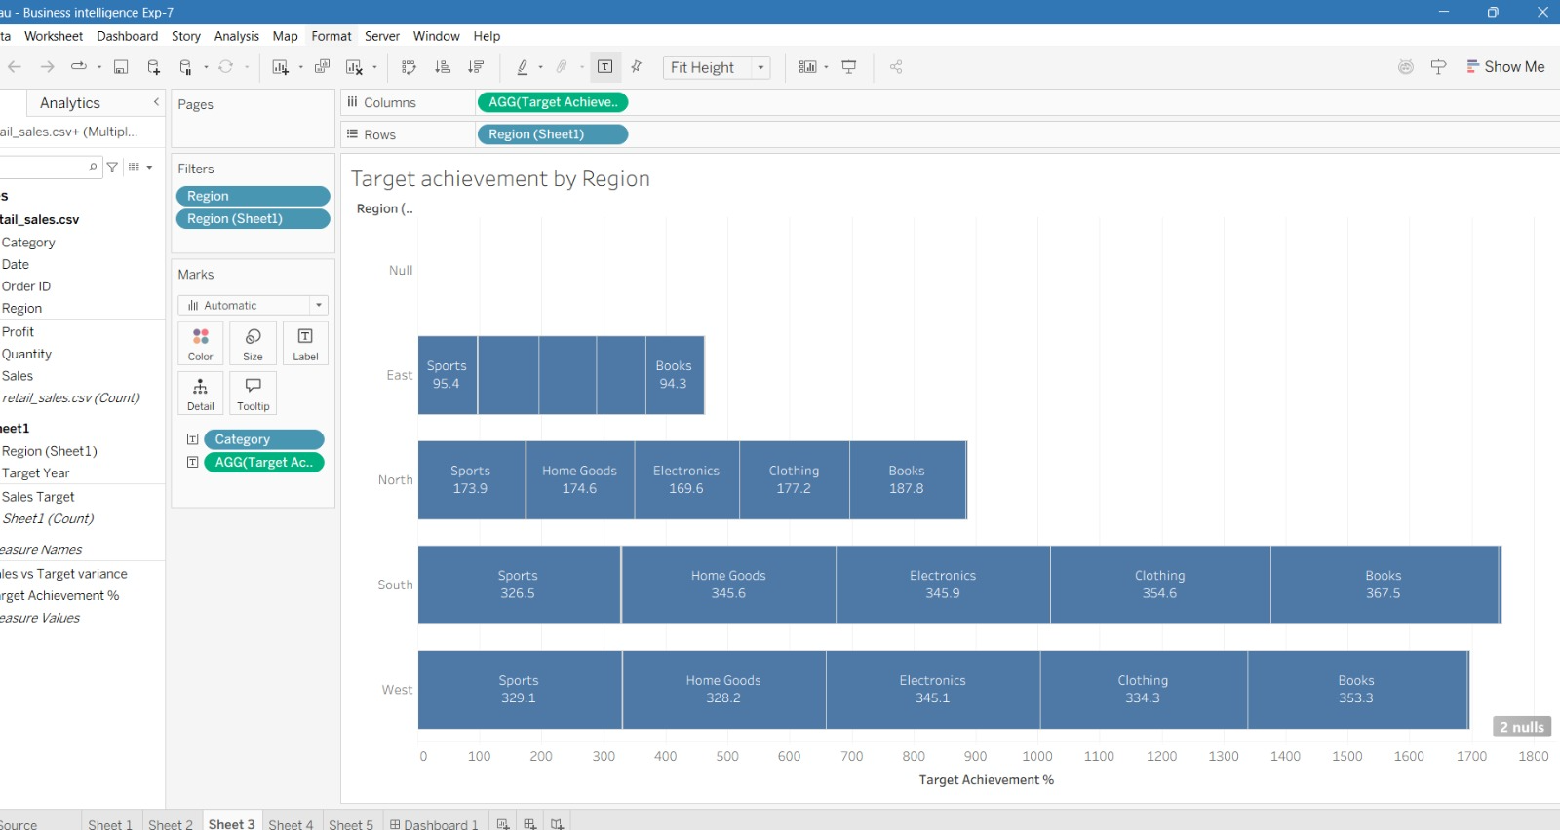

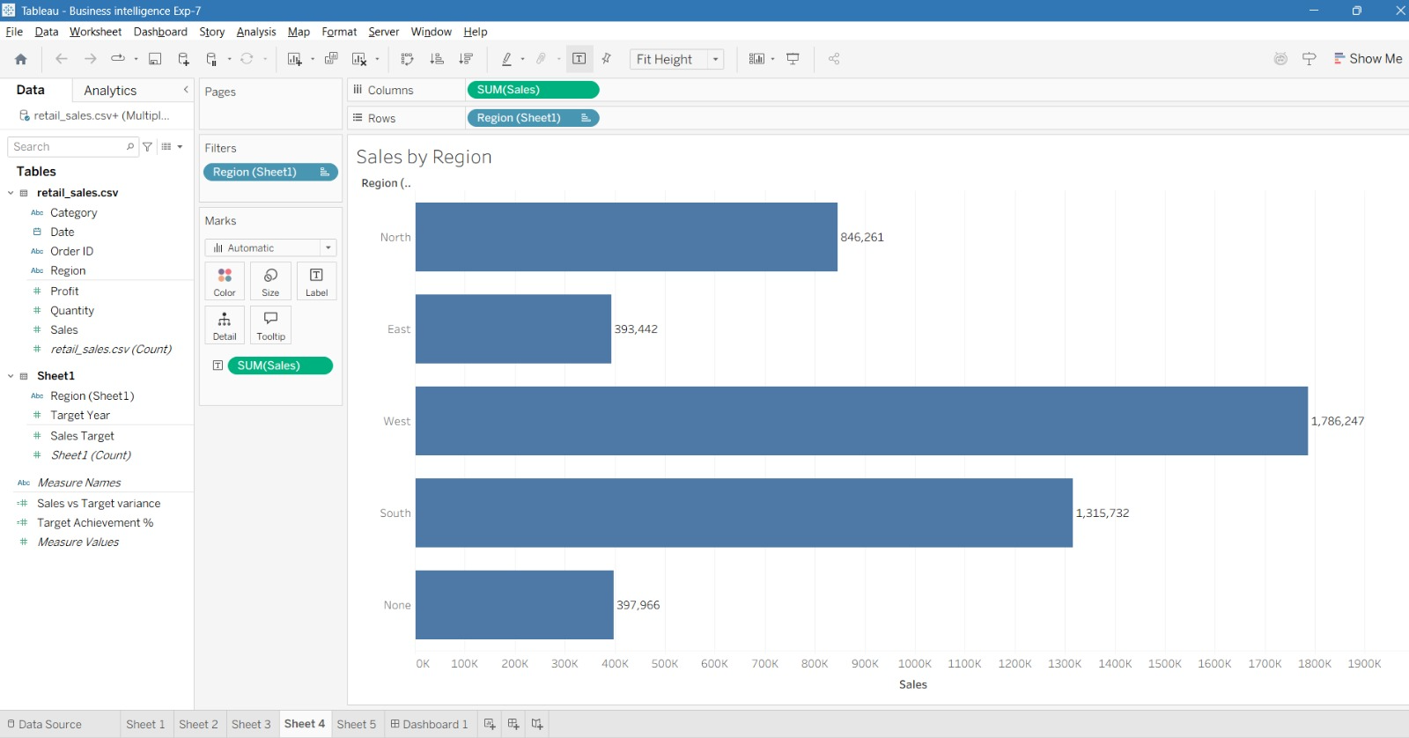

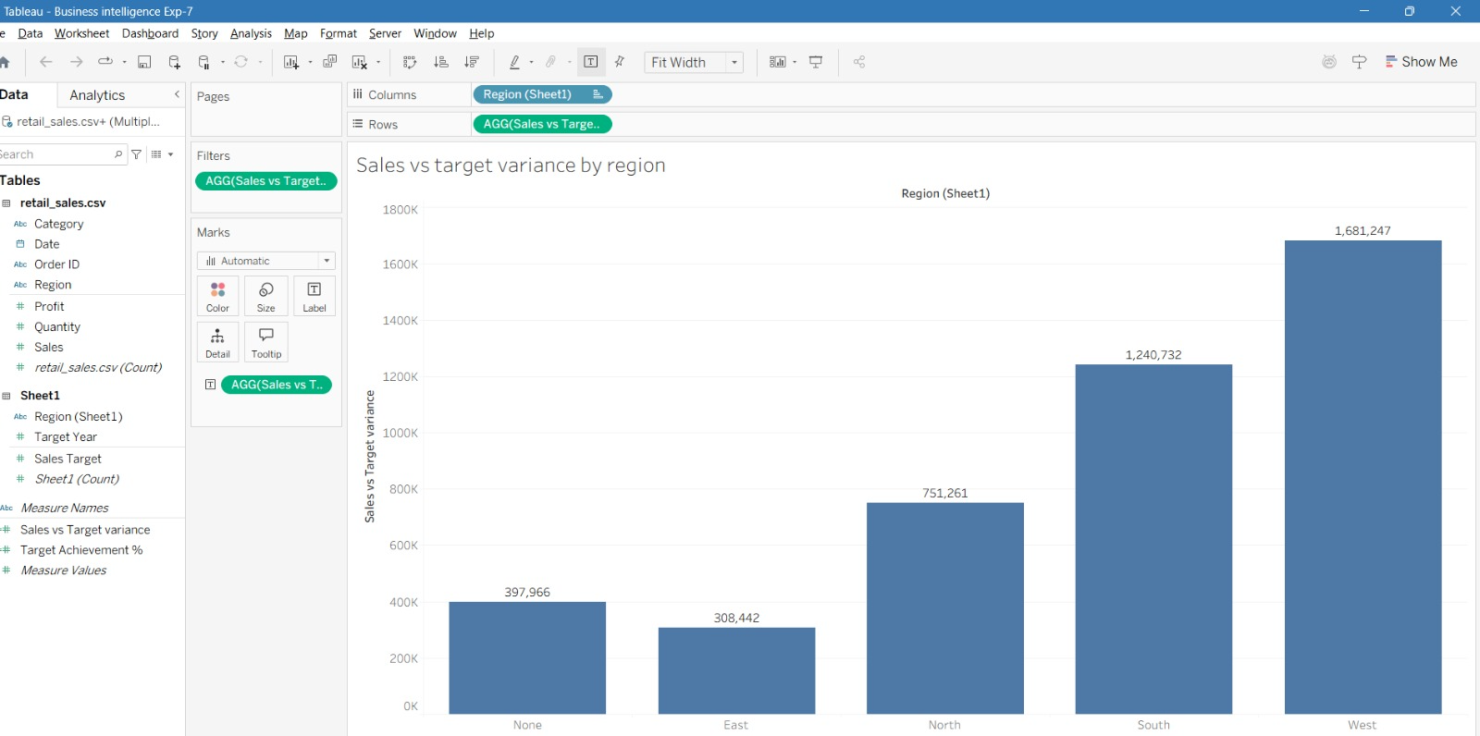

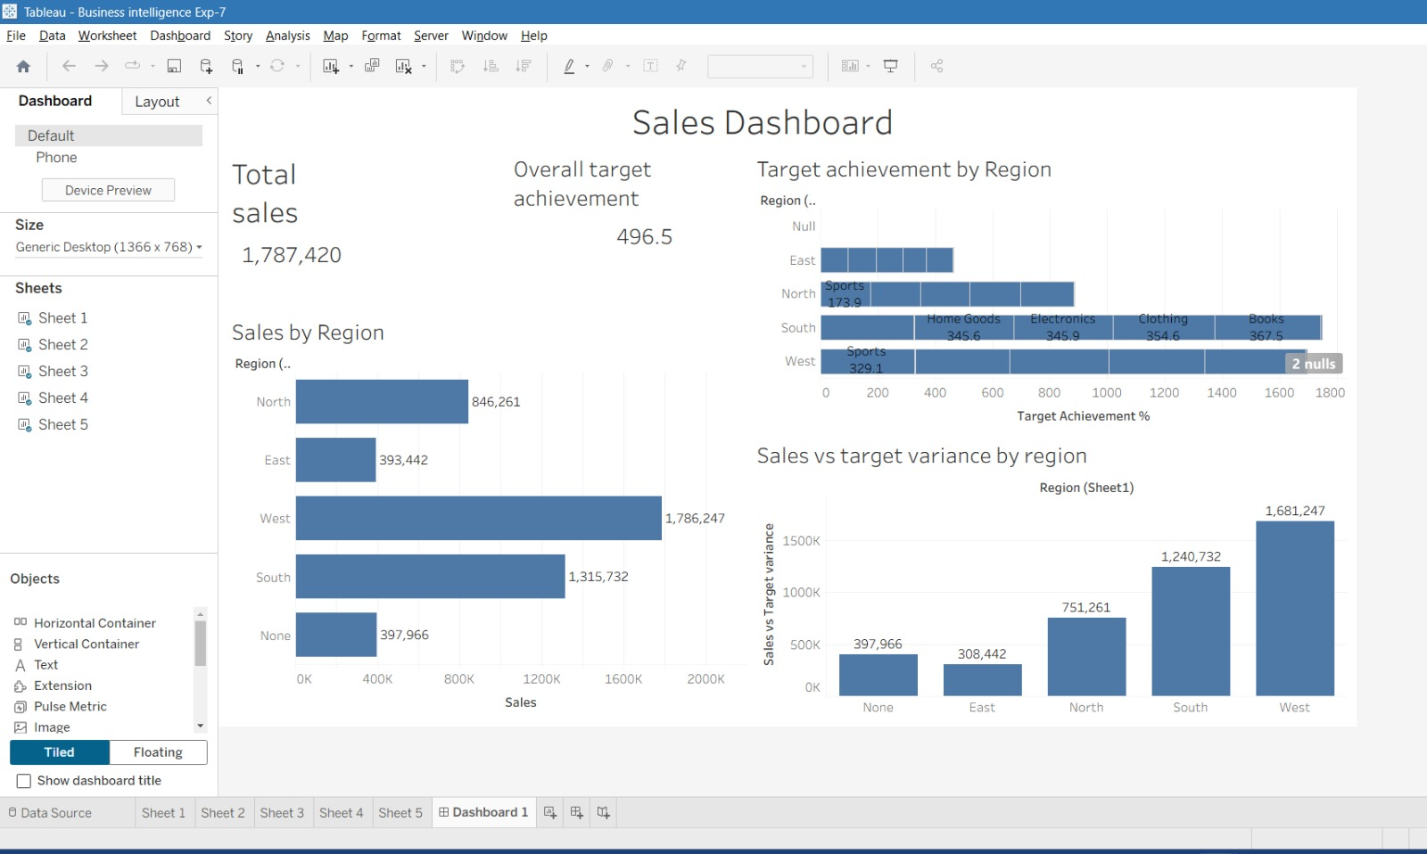

POST-LAB QUESTIONS (PROVIDE BRIEF ANSWERS TO THE FOLLOWING QUESTIONS)

- How did integrating the sales targets data provide a more complete analytical picture than using the sales data alone?

Integrating sales target data allowed us to compare actual sales with planned targets. Sales data alone shows how much was sold, while target data helps determine whether the business achieved its expected performance. This provides a clearer view of performance by region, product, or time period.

- Describe the type of join or relationship you used to combine the two datasets and explain why it was the appropriate choice.

A left join can be used to combine the datasets using a common field such as Region or Product. This ensures that all sales records are retained while the corresponding target information is added where available. It is appropriate because the sales data is the primary dataset being analyzed.

- What challenges, if any, did you face regarding data granularity or mismatched keys (e.g., different region names) between the two sources?

One challenge can be different naming conventions, such as “North Region” in one dataset and “North” in another. Differences in data granularity can also occur if sales data is recorded monthly while targets are recorded annually. These issues need to be standardized before integration.

- How can creating variance calculations (e.g., Sales vs. Target) help a business manager make better decisions?

Variance calculations show whether actual sales are above or below the target. Managers can quickly identify underperforming regions or products and take corrective actions. Positive variance indicates that sales exceeded expectations, while negative variance highlights areas requiring attention.

- What other data source (e.g., marketing campaign data, customer demographics) could you integrate to further enrich this analysis, and what new insights might it provide?

Marketing campaign data could be integrated with the sales data. It could help determine whether marketing campaigns increased sales and which campaigns generated the best results. This would allow managers to allocate marketing budgets more effectively.

RESULT:

The retail sales and regional targets datasets were successfully connected, cleaned, and integrated in Tableau and Power BI. Relationships between the sources created a unified data model. The dashboard visualized sales performance against targets, enabling variance analysis and providing insights into regional performance not possible with a single data source.

ASSESSMENT

Description | Max Marks | Marks Awarded
Pre Lab Exercise | 5
In Lab Exercise | 10
Post Lab Exercise | 5
Viva | 10
Total | 30
Faculty Signature

